

sdf
ONLINE FUNDRAISING: RAISE $ & WIN

With your parent’s help: sign up online at studentseries.org.
Find your school then create your fundraising page.
Share your link with family and friends

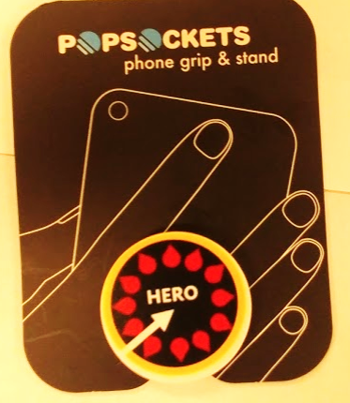
EXCLUSIVE FOR GREATER BAY AREA
MIDDLE & HIGH SCHOOL STUDENTS
HERO POPSOCKET
Middle School students can win limited edition
HERO POPSOCKET by being one of the top 5 online fundraising students at their school.
Must raise $100 to be eligible.


HERO SQUAD TSHIRT
Students who raise $50 online using their own fundraising pa ge can earn a Hero Squad Tshirt!

